ENGG-100: Measurement & Design Lab
Project Report
Session: Spring 2024


Department of Electrical Engineering
Syed Babar Ali School of Science and Engineering
Lahore University of Management Sciences
Pakistan

Abstract

The project involved designing and implementing the PathTracer robot as part of the ENGG 100 course. The robot's primary functions included line-following and obstacle-avoidance. It began by detecting a blue starting line using a color sensor, followed a black line via infrared sensors, and navigated an obstacle zone with ultrasonic sensors. At the end of the course, it performed a U-turn and returned to its starting position, completing the journey in reverse. The robot achieved consistent performance during trials, successfully integrating sensors, motors, and control logic. Challenges such as sensor calibration were addressed effectively, and future improvements could include enhancing speed, path complexity, and sensor sensitivity. The project offered valuable insights into engineering design, robotic systems, and teamwork, providing a hands-on application of theoretical knowledge.

Contents
Abstract ii
Contents iii
List of Figures iv
List of Tables v
Project Main Title 1
1.1 Introduction 1
1.2 Schematics 2
1.3 Task 1 2
1.4 Task 2 2
1.5 Implementation 3
1.6 Result and Analysis 3
1.7 Conclusion 3
1.8 Work Contribution 3

List of Figures

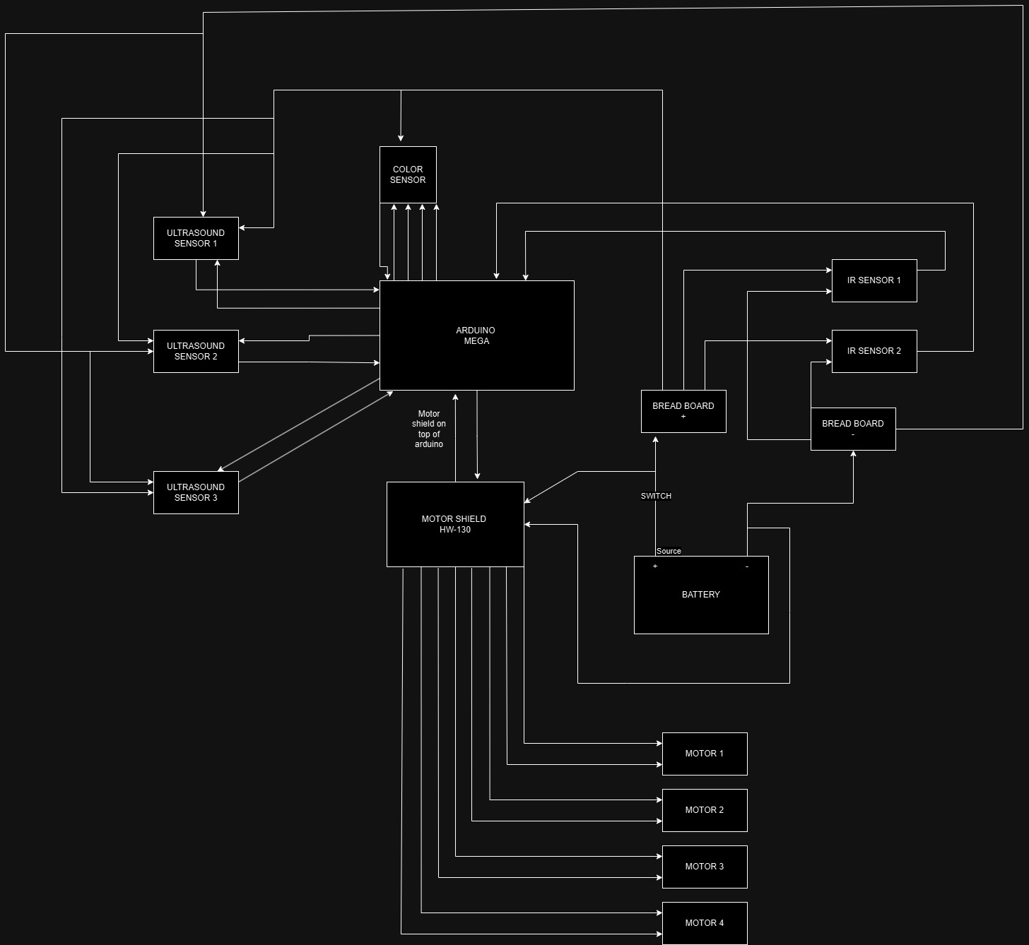

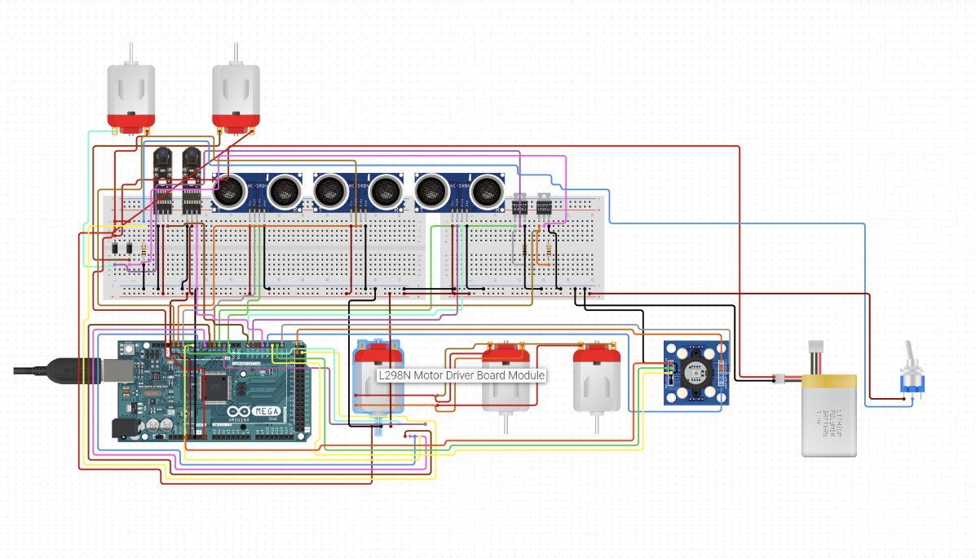

PathTracer Robot

1.1 Introduction
The PathTracer robot was developed by applying the knowledge and hands-on experience gained from the ENGG 100 course. The main focus of the project was to build a robot capable of performing line-following and obstacle-avoidance tasks. The robot begins its journey by aligning itself on a designated blue line and tracing a black line, adjusting its position and direction to stay on course. After completing the black line, it navigates through an obstacle zone by avoiding blocks using sensors. At the end of the course, the robot performs a U-turn maneuver and retraces the black line in reverse, ultimately stopping at the same blue line where it started. This project is the integration and the practical demonstration of the skills we gained from this course.

1.2 Schematics


UPLOADED ON LMS

1.3 Implementation/methodology
To detect the starting and ending points, a color sensor was used to identify the blue line, marking the beginning and conclusion of the robot's journey. For line following, two infrared sensors were strategically positioned to detect the white boundaries of the black line. When one of the sensors detected black, the wheels on that side of the robot moved backward, enabling it to make a smooth turn while considering the robot’s weight distribution. For obstacle avoidance, three ultrasonic sensors were used: one facing forward and two facing sideways. The robot was programmed to maintain a set threshold distance from nearby obstacles based on readings from these ultrasonic sensors, ensuring seamless navigation through the obstacle zone.

1.4 Task 1
The first task was building the chassis of that which was relatively simple, then came the testing of the components to ensure they worked properly which was also not that time taking, the wiring for the components was quite tedious however we managed to get a strong wiring and then places our sensors and other components on the chassis. This concludes the building of the robot car.
The first part of the course which was line following required IR sensors, which after adjusting tell the robot if any of them are on a black line. Which ever of the left or right sensors is on a black line, the car turns towards that direction, in turn following the line we adjusted the delay and speed for maximum accuracy for this task.

1.5 Task 2
This was the 2nd half of the project which involved the obstacle avoiding track. This was by far the hardest task to adjust as the delay timings were key for a smooth operation on this part. We had the frequently adjust the threshold values to get it just right for our car. We also added functions that take a more stable reading from the ultrasound sensors using averaging methods. The U-turn at the end of the course was quite interesting to code however we feel like the hardest part was to keep the car centered and away from walls to ensure the sensors work as intended.
This task also included the executing condition of the code which was when blue color was detected by the color sensor, which also after calibrating our values worked nicely. The color sensor in our code is like a check function of sorts, it changes what code is getting executed depending on the color received by the sensor, on blue the car moves forward, on any color except red and blue, the line following code is executed, on red, the obstacle avoidance code is executed instead this happens when the line track is finished and the only color on the floor is red at the obstacle track. The code also stops when it detects blue a second time, which shows the completion of the track.

1.7 Results and Analysis

The robot called PathTracer managed to perform its intended operations of line following and also obstacle avoidance efficiently. The color sensor started and ended detecting the blue line accurately, and the IR sensors made sure that the robot was always on the black line. The ultrasonic sensors made it possible to pass through the obstacle area without hitting anything or coming too close. The robot had no trouble performing the U-turn and the journey back and completed the course in a consistent manner in most of the trials performed. Some small problems were witnessed when the sensors were first calibrated for the motors, which were then sorted during normalization. With regard to enhancement, future research should seek to increase speed, increase the complexity of the paths, and sensitivity of the devices. To sum up, the project proved to be effective in achieving the engineering objectives set forth and captured important lessons in engineering design and robotic systems operation as well as dealing with practical problems.

1.8 Conclusion
This project was a valuable learning experience that significantly enhanced our technical skills, teamwork, and adaptability. We learned how to integrate and extract data from sensors, including IR, ultrasound, and color sensors, and gained hands-on experience in programming robots to function according to specific requirements. Additionally, the project improved our troubleshooting and debugging abilities as we worked through various challenges. Collaborating as a team of two helped us develop essential teamwork skills, such as dividing tasks effectively and brainstorming solutions for errors together. Moreover, the frequent challenges and evolving problems we encountered while writing the code taught us the importance of adaptability and perseverance in problem-solving. Overall, this project gave us the opportunity to learn and to practically utilize the knowledge attained.

1.9 Work Contribution

Member 1:
- Line follower code and logic
- Obstacle avoid logic and code
- Color sensor code
- General coding

Member 2 Muhammad Sheheer Masood:
- Wiring for the components
- Building the chassis
- Line follower code and logic assist
- Obstacle avoid logic and code
- Stabilizing the code
- Error checking
- General coding

